Development
Introduction
The Academic Performance Decision Support System (DSS) was developed using an iterative development approach. This method allowed the system to be built step by step through several development stages. In each stage, a specific feature was designed, a prototype was created, the functionality was tested, and the results were reviewed. Based on the findings from each stage, necessary improvements were made before moving on to the next step.
This approach helped me to identify and resolve issues early in the development process. It also ensured that the final system closely aligned with the requirements and objectives that were identified during the analysis phase.
The system was implemented using the Python programming language due to its extensive support for database management, graphical interfaces, and data processing. Several Python libraries were used to support development, including:
Library | Purpose
Tkinter | Graphical User Interface
SQLite3 | Database storage
Matplotlib | Data visualisation
ReportLab | PDF report generation
CSV | Importing student data

The solution was designed to be modular and maintainable, with different sections of the program responsible for different tasks such as database management, data processing, decision support analysis, and user interface management.
Iteration 1 (Database model) – 03-March-2026
Objective
The first stage of development focused on creating a system that could permanently store student records that were extracted from the college Virtual Learning Environment (VLE) in a CSV file. The aim was to ensure that the data could be saved and easily accessed by the application when needed.
The database was designed to store key pieces of student information, including:
- Student ID
- Student Name
- Module
- Average
- Attendance
- Homework Completion
Code Snippet
Defines the database file name

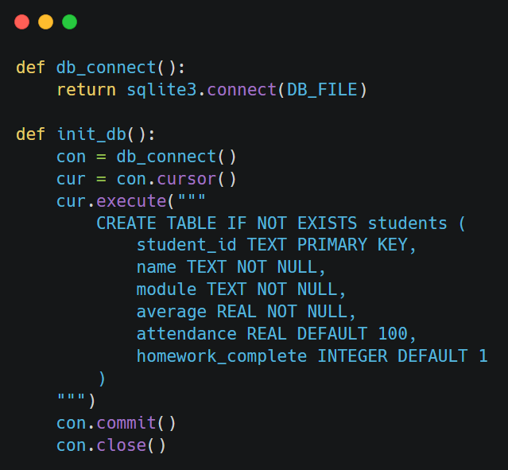

Opens a connection to the DB file

Establishes DB connection

Creates a cursor to execute SQL commands

creates the students table only if it does not already exist

Commit and close connection

Justification
SQLite was chosen as the database system for several reasons. First, it integrates easily with Python, making it straightforward to connect the database with the application. It also does not require a separate server installation, which simplifies the setup process and reduces system complexity.
In addition, SQLite is well suited for small-scale desktop applications like this project, as it is lightweight while still providing reliable data management. It also allows the system to store student information permanently, ensuring that the data remains available even after the application is closed.
To maintain data integrity, the student_id field was set as the primary key. This ensures that each student record is unique and prevents duplicate entries from being added to the database.
Testing
The database functionality was tested to ensure that student records could be stored, retrieved, and updated reliably. Testing focused on verifying that the database structure worked as intended and that student data was saved permanently and remained accessible across multiple runs of the application.
Test Case | Test Description | Expected Outcome | Result
Database creation | Run application with no existing database file | Database file and student table created successfully | Pass
Insert valid record | Manually insert a valid student record into database | Record stored correctly in database | Pass
Retrieve records | Reload application after closing | Previously stored student records loaded correctly | Pass
Unique student ID | Attempt to insert a record using an existing student ID | Duplicate prevented or existing record updated | Pass
Data storage | Close and reopen application | Student data retained in database | Pass
Invalid data type | Attempt to insert text into numeric database field | Error handled, record not stored | Pass
Missing required field | Attempt to insert record with missing required values | Insert rejected, error reported | Pass

Problems Encountered and Solutions
During testing of the database model, few test cases initially failed. These failures were expected at this stage of development and helped identify areas requiring improvement in later iterations.
Problem 1: Duplicate student ID
When attempting to add a student with an ID that already existed, the database raised an error and stopped the insertion. Validations were not added to handle this error.

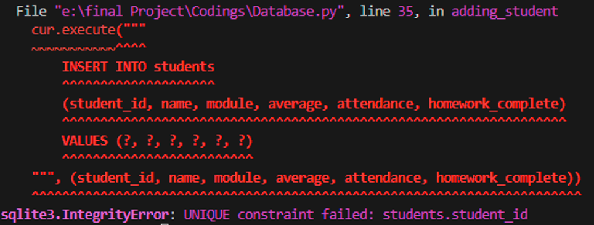
Solution:
This behaviour was accepted at this stage as it confirmed that the database correctly prevents duplicate records using a unique student ID. In later iterations, this was improved by handling the error more smoothly.
Problem 2: Invalid data type
When text was entered into numeric fields such as average or attendance, the database produced an error.
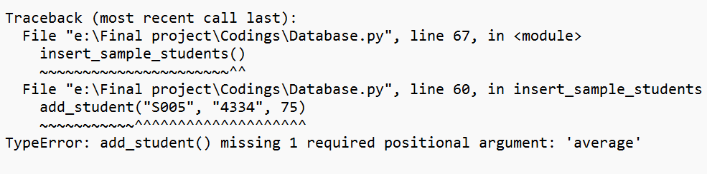
Solution:
This highlighted the need for input validation. Error handling and validation were added in later stages to prevent incorrect data from being inserted.
Problem 3: Missing required fields
Records with missing mandatory information could not be inserted, causing an error.
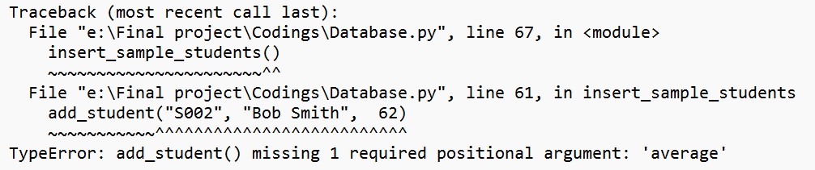
Solution:
The database constraints worked as intended by rejecting incomplete records. User-friendly validation and error messages were added in later iterations to improve system reliability.
Iteration 2 (Student data model) – 07-March-2026
Objective
The second stage of development focused on creating an object-oriented data model to represent student records within the system. Using objects helps organise the program more effectively and makes the code easier to maintain and expand in the future.
Implementation
A Student class was created to represent each individual student record stored in the system. Each object of the class holds the data imported from the CSV file and saved in the database, including details such as student ID, name, module, average score, attendance, and homework completion.
The class provides functions that give useful insights from the data.
- At-Risk Detection: Checks if a student’s average score is below 50 and flags them as “at risk,” helping identify students who may need additional support.
- Predicted Grade: Estimates a student’s final grade by considering average score, attendance, and homework completion. Attendance below 90% or incomplete homework reduces the score slightly, and the final letter grade (A–E) is assigned based on the adjusted score.
- Suggested Intervention: Recommends support measures depending on performance. High scorers require no intervention, mid-range students may be encouraged to practice or receive extra tutoring, while students below 50 are flagged for immediate intervention.
This design ensures that actionable insights are generated automatically for each student object without altering the original data imported from the CSV file.

Code Snippet
Constructor method to initialize student details
Define a class called Student
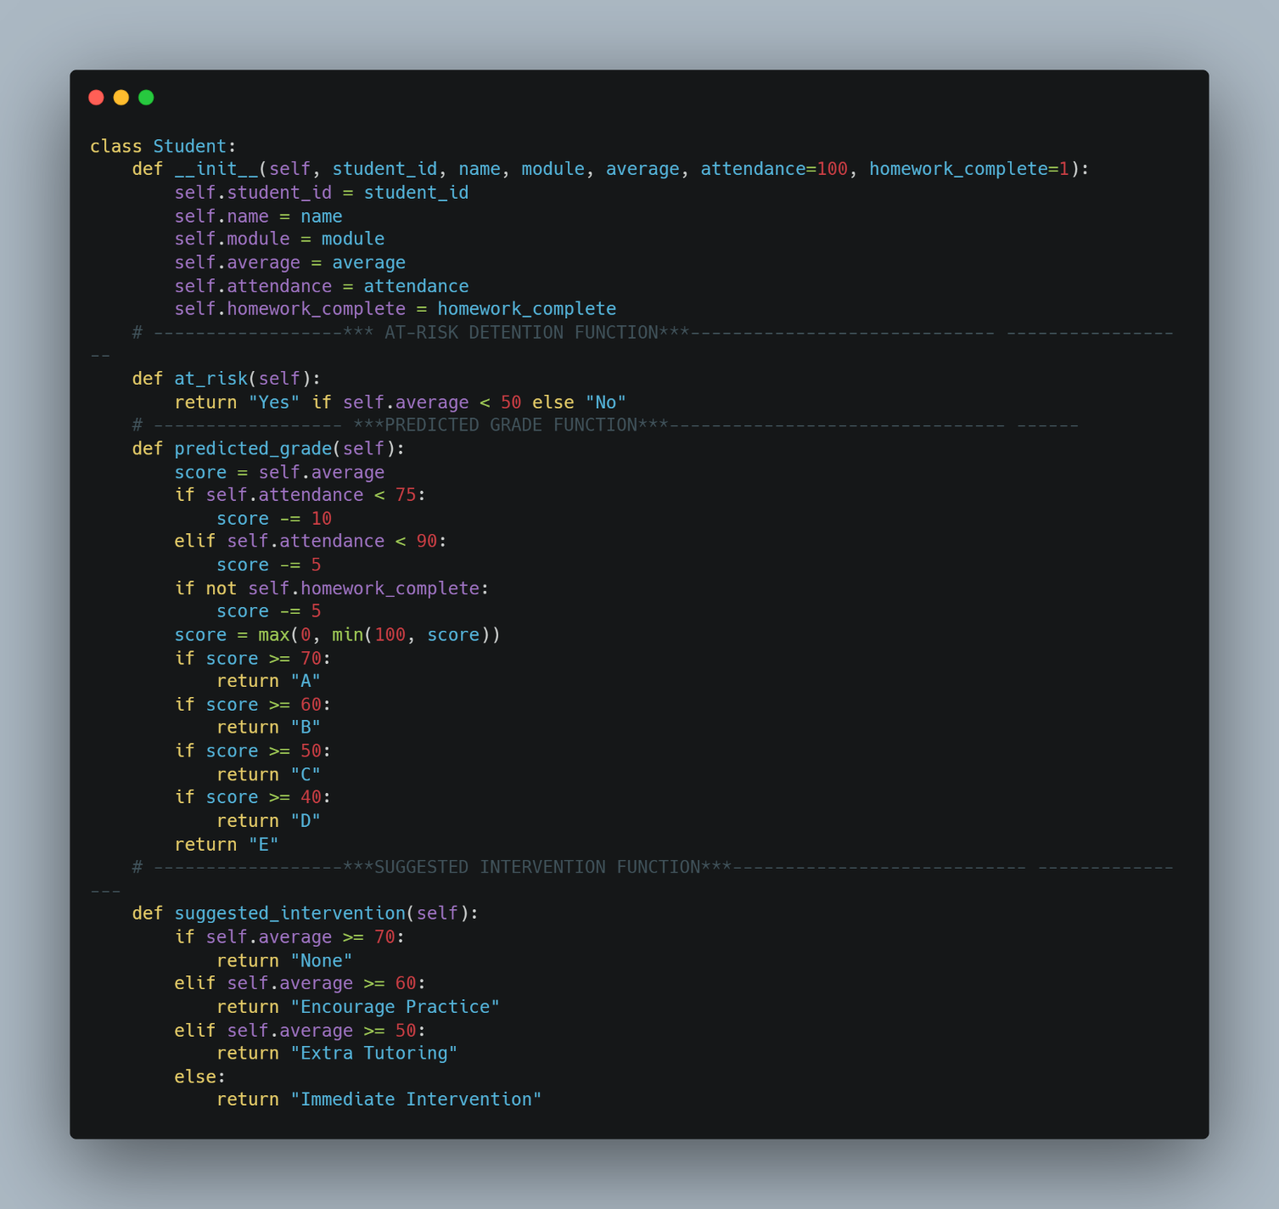

A function to Checks if the student is at academic risk

A function to calculate the predicted grade based on average, attendance, and homework

A function to Suggests academic support based on the student's average

Justification
Using an object-oriented design has several benefits. It keeps all student-related data together in one organised structure, making the system easier to understand. This improves how the code is organised and makes it more readable and modular. It also makes the system easier to maintain, update, and fix when needed. In addition, it allows the program to handle multiple student records efficiently and automatically generate useful insights.
Testing
Testing confirmed that student records stored correctly and accessed accurately. The system also successfully flagged at-risk students, predicted grades, and suggested interventions based on the imported data.
The following sample was created to test the student class
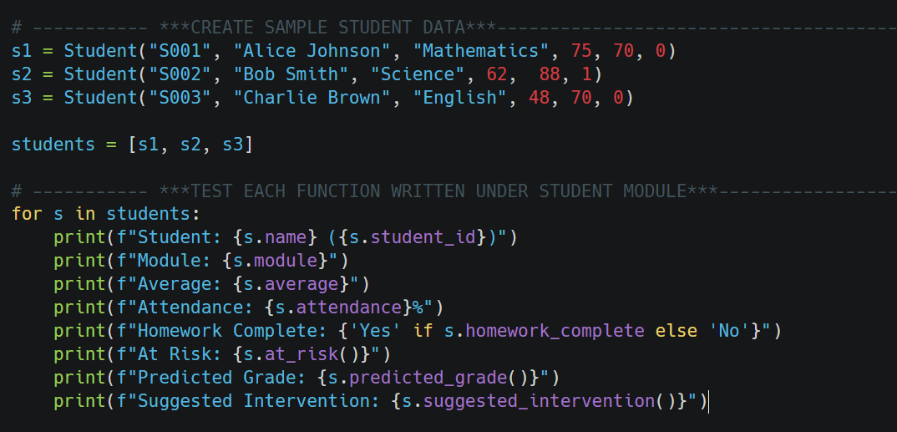

Test cases
Test Case | Test Description | Input Data | Expected Outcome | Result
Create student | Create student object with valid data | Student("S01", "Daniel Carter", "M205", 65, 85, 1) | Student object created successfully | Pass
Store attributes | Assign values to all fields | ID: S01, Name: Daniel Carter, Module: M205, Average: 65 | All values stored correctly | Pass
At-risk status | Check at-risk status for low average | Average = 45 | At-risk returns "Yes" | Pass
Not at risk | Check at-risk status for acceptable average | Average = 55 | At-risk returns "No" | Pass
Predicted grade | Calculate grade with good performance | Average = 72, Attendance = 92, Homework = 1 | Correct grade returned (A) | Pass
Predicted grade penalty | Calculate grade with penalties applied | Average = 72, Attendance = 70, Homework = 0 | Grade reduced correctly | Pass
Suggested intervention | Low performance intervention | Average = 48 | "Immediate Intervention" returned | Pass
No intervention needed | High performance intervention check | Average = 75 | "None" returned | Pass

Problems Encountered and Solutions
Duplicate Student Records
student_id filed accepted duplicate entries.
Solution: The student_id field was set as the primary key in the database, preventing duplicate records.

Iteration 3 (Student-Academic-Performance-DSS UI)- 27-Feb-2026
Objective
The main objective was to provide a clear, user friendly interface that allows users to interact with student performance data efficiently while supporting different user roles within the system.
Implementation
The user interface was developed using the Tkinter and ttk libraries in Python, which provide standard GUI components suitable for desktop applications.
The user interface consists of two primary windows:
Login Window
The login interface allows users to authenticate themselves before accessing the system. It includes:
• A username input field
• A password input field with masked characters
• A Login button to validate credentials
• A Reset button to clear all input fields
User credentials are validated against a predefined in memory data structure. Upon successful login, the system identifies the user’s role and launches the main dashboard interface accordingly. If the credentials are invalid, an error message is displayed to notify the user.
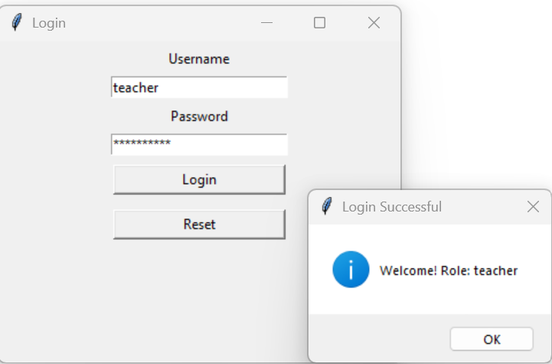
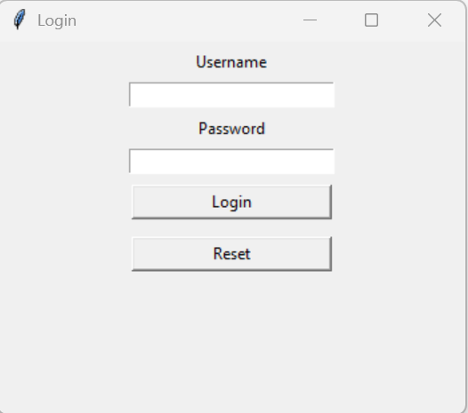
Successful login message
Login Screen UI

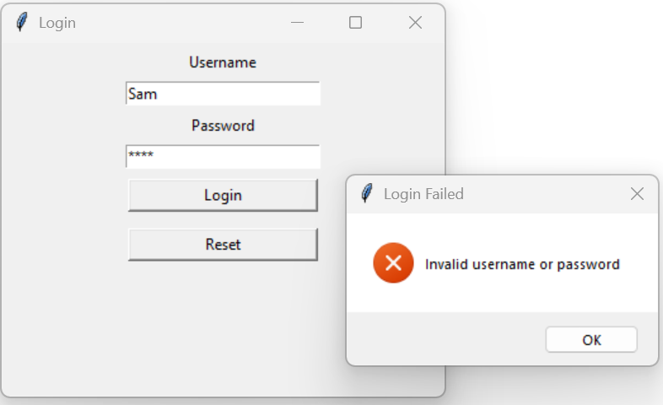
Unsuccessful login message

Main Dashboard Window
After authentication, users are redirected to the Academic Performance DSS dashboard, which serves as the central hub of the system. The dashboard includes:
• A role-based toolbar containing action buttons
• A student data table for visualising academic performance data
Role Based Interface
The system supports two user roles:
Teacher role
Teachers are granted access to additional administrative and analytical functions, including:
- Import CSV
- Refresh data
- Sort Table
- Search students
- Module distribution
- At risk status
- Predicted grade
- Suggested interventions
- Export report

A vertical scrollbar is included to support larger datasets. Sample student data is used in this iteration to demonstrate the layout and behaviour of the interface.
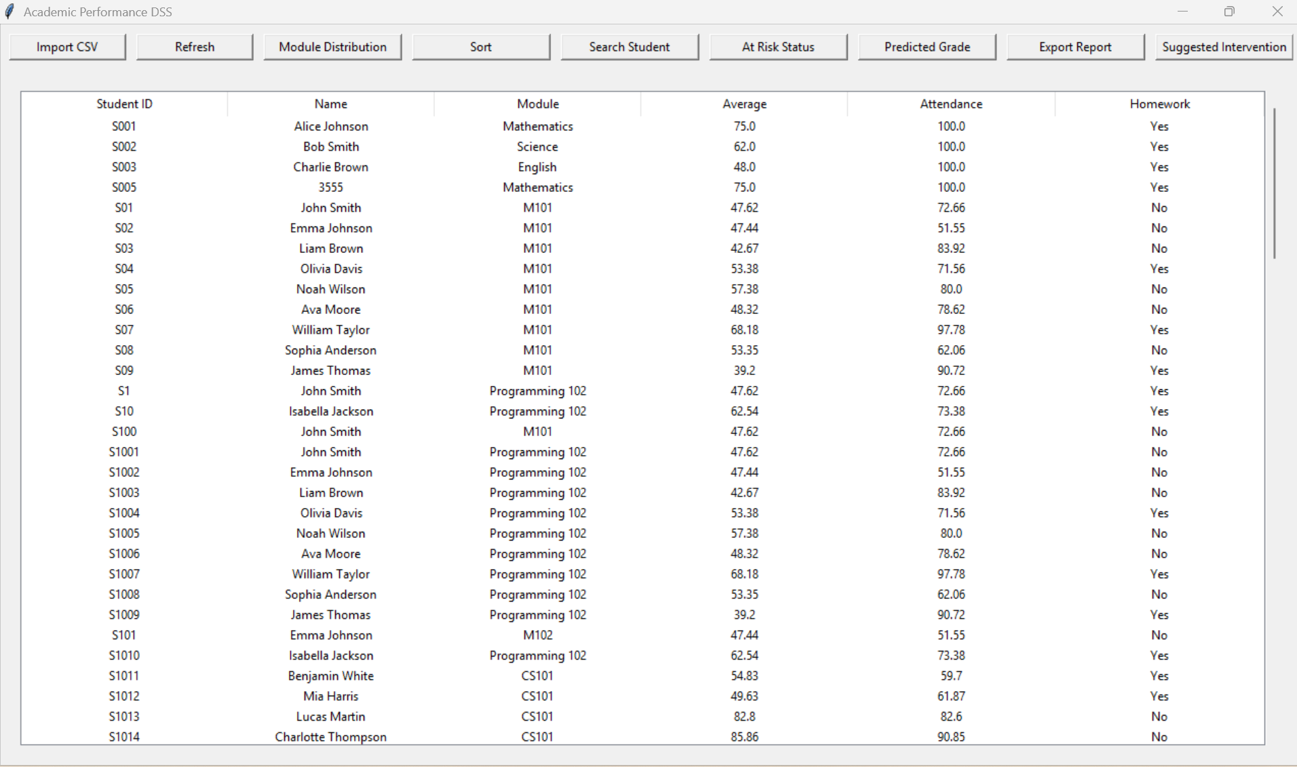
The main dashboard for teachers

Parent role
Parents have access only to informational features and cannot modify data.
This role-based UI design ensures that users see only the functions relevant to their responsibilities, improving usability and security. Parents can only search for their child, view the at-risk level, suggested interventions, predicted grade, and export the report. A pop-up message is displayed when the at-risk level, suggested interventions, or predicted grade buttons are clicked, showing the student’s performance details.

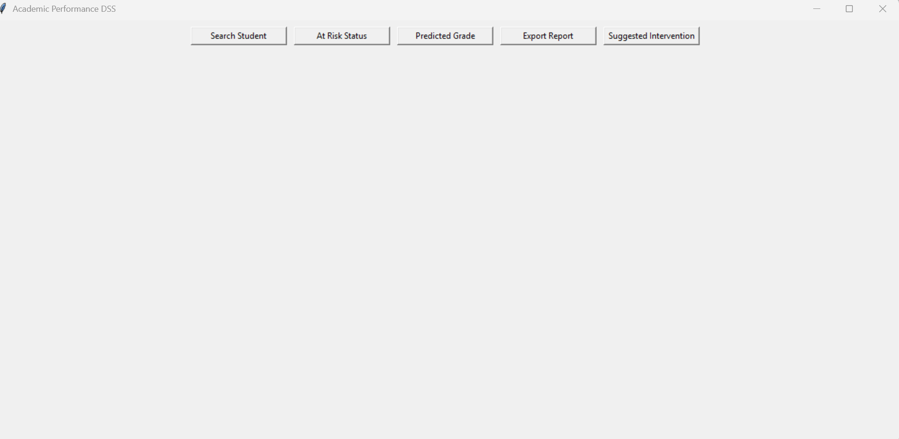
The main dashboard for parents

Code Snippet for the main window UI
Function to build the main application window based on user role
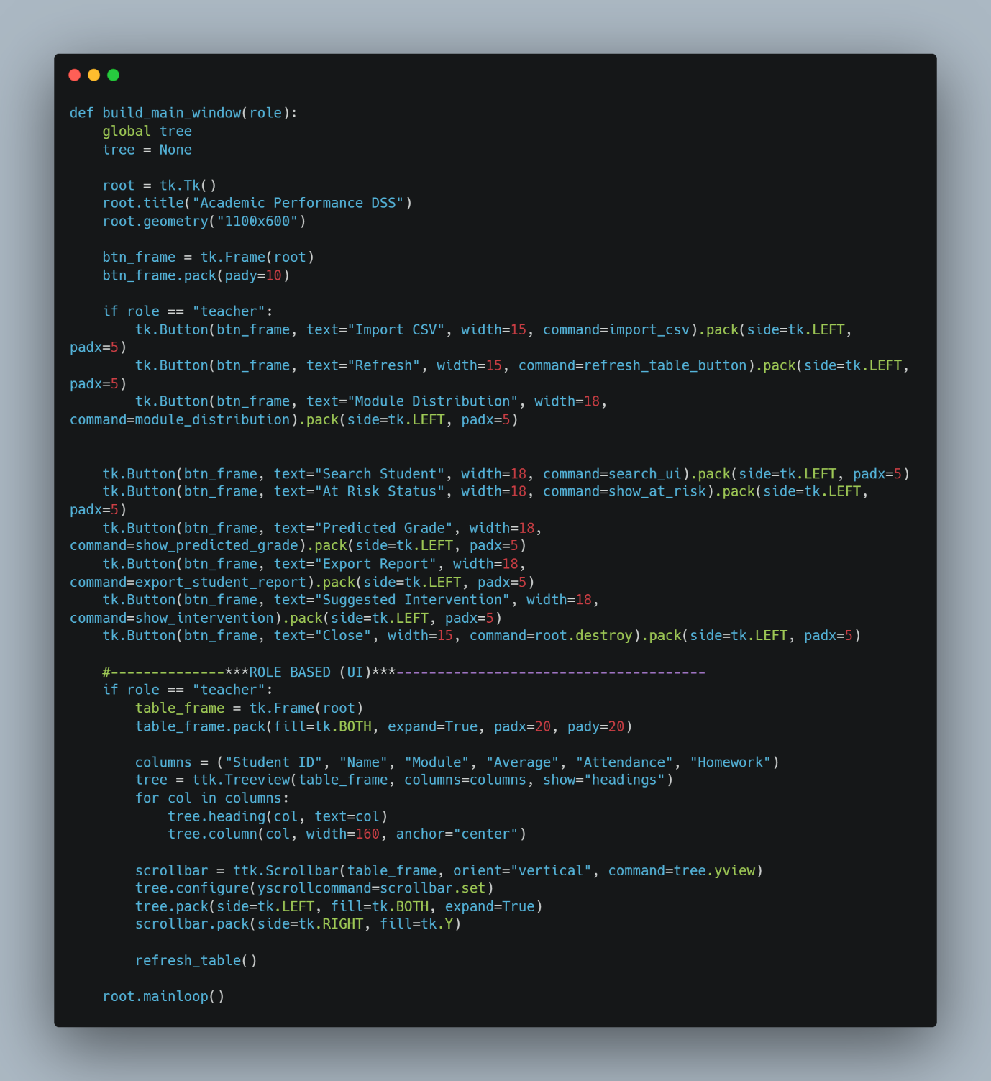

Create the main window

These buttons appear only if the user role is teacher

Common buttons for all users

If the user is a teacher, display the student data table

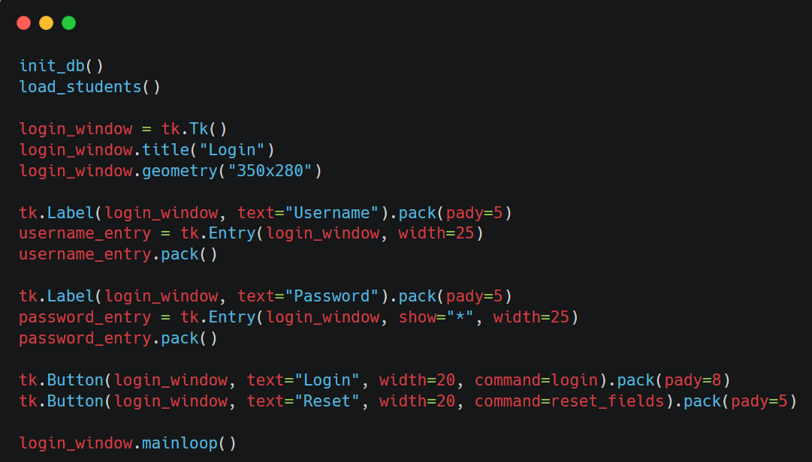
Code snippet for the login UI
Create the login window
User name input

Password input

login button

Reset button

Justification
The user interface design was developed to provide a clear, structured, and easy-to-use experience for all users. Separating the login interface from the main dashboard improves clarity and security by ensuring that authentication is completed before access to system features is granted. This reduces the risk of unauthorised access and supports controlled system navigation.
The interface also implements role-based access control at the user-interface level. Different features are displayed depending on whether the user is a teacher or a parent, ensuring that users only see functionality relevant to their role. This improves usability while also helping to protect sensitive student data.
Reusable interface components such as buttons and tables were used consistently throughout the application. This improves visual consistency and reduces code duplication, making the system easier to maintain and modify. The modular structure of the interface also supports future expansion, as additional features can be added without requiring major changes to the existing layout.
Tkinter was chosen as the interface toolkit because it is platform-independent and integrates directly with Python. This allows the application to run on multiple operating systems without modification and supports rapid development and testing of the interface. Overall, the design choices create a user interface that is efficient, maintainable, and suitable for the requirements of the system.

Test cases
Test Case | Test Description | Input Data | Expected Outcome | Result
Successful login | Log in with valid teacher credentials | Username: teacher  Password: teacher123 | Teacher dashboard loads correctly | Pass
Successful login (parent) | Log in with valid parent credentials | Username: parent  Password: parent123 | Parent dashboard loads correctly | Pass
Invalid login | Log in with incorrect credentials | Username: teacher  Password: wrongpass | Error message displayed | Pass
Role-based UI | Compare teacher and parent interfaces | Teacher vs Parent login | Teacher sees admin controls; Parent sees restricted view | Pass
Table display | Load student records into table | Sample student data | All records displayed correctly | Pass
Scrollbar behaviour | Scroll through table with many records | Multiple student rows | Scrollbar allows smooth navigation | Pass
Reset fields | Click reset on login screen | Username and password entered | Fields cleared correctly | Pass
Input focus | Reset then attempt new login | Reset button clicked | Cursor ready for new input | Pass

Problems Encountered and Solutions
1. UI Clutter with Multiple Buttons
The toolbar initially appeared cluttered with all controls displayed together.
Solution:
Removed the close button to avoid this issue.

2. No Backend Integration in Early Stage
The UI initially lacked real data sources and analytics.
Solution:
Sample student data was used to design and test the UI layout, enabling smooth integration with the data model and database in later iterations.

Iteration 4 – CSV Import module (07-3-2026)
Objective
The aim of this iteration was to allow student data to be imported from a CSV file into the system automatically. This reduces the need for manual data entry and allows student records exported from the college Virtual Learning Environment (VLE) to be added quickly and accurately to the application’s database.
Implementation
The CSV import feature is implemented using Python’s built-in csv module and an SQLite database. When triggered, a file dialog allows the user to select a CSV file, and the function exits safely if no file is chosen. The program ensures the student table exists, then reads the file using csv.DictReader and inserts each row into the database using an INSERT OR REPLACE statement to avoid duplicates.
Numeric values are converted appropriately, with default values used where needed, and data is standardised for consistency. After processing, changes are saved, the database is closed, and the user interface is refreshed. Basic error handling is included to manage issues such as missing files, invalid data, or missing columns.

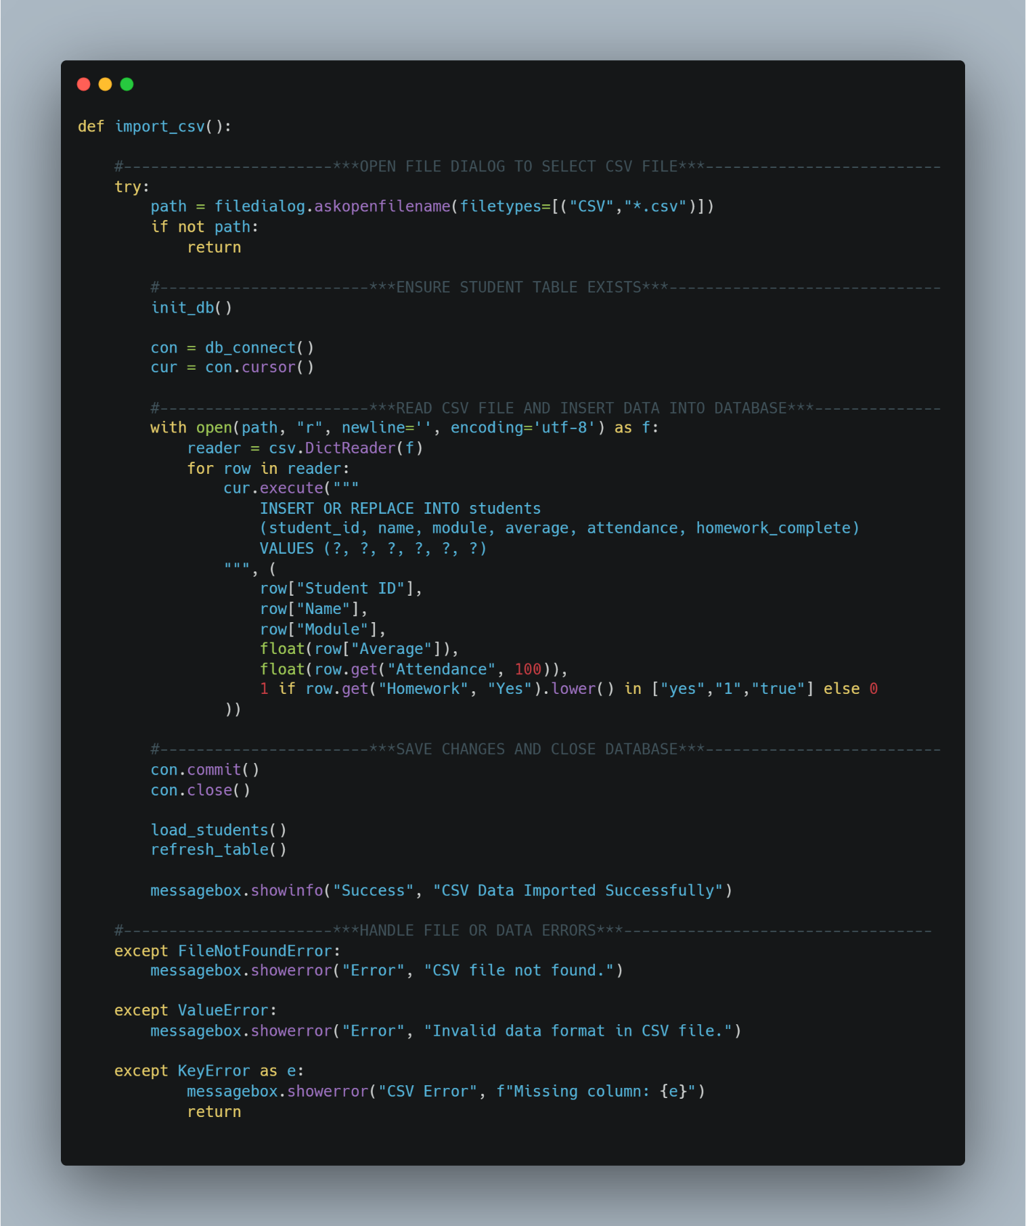
Code snippet

Allows the user to select an external CSV file using a file dialog.

Prevents execution if no file is selected by the user.

Ensures the required database table exists before processing data.

Establishes a database connection and cursor to execute SQL commands.

Reads structured CSV data using column headers as dictionary keys and process each student record sequentially.

Maintains data integrity by preventing duplicate student records

Saves all database changes and releases system resources safely.

Error handling for missing csv file, invalid data formats & missing required columns

Justification
CSV was chosen as the import format because it is widely supported and easily exported from spreadsheet software and learning platforms. Using Python’s built-in csv module provides a reliable and simple way to read structured data while reducing the risk of file formatting issues.
The use of INSERT OR REPLACE improves data integrity by ensuring that each student record remains unique based on student ID. This avoids duplicate entries and allows updated data to overwrite older records when needed.
Including exception handling improves the robustness of the system by preventing crashes and providing clear feedback when errors occur. Overall, the design is suitable for the size and purpose of the application and supports efficient data management.
Testing
The CSV export feature was tested using several different scenarios to ensure it works correctly in different situations.
Test Case | Input Data | Expected Outcome | Result
Valid CSV import | Correct CSV file selected | Student records imported successfully | Pass
Duplicate student ID | CSV containing existing ID | Record updated, no duplicate created | Pass
Cancel file selection | Cancel file dialog | Import safely cancelled | Pass
Invalid data format | Text in numeric field | Error message displayed | Pass
Missing CSV column | Column removed from CSV | Error message displayed, import stopped | Pass

Problems Encountered and Solutions
During the development of the CSV import feature, several issues were identified and resolved to improve reliability and usability.
Issue 1: Duplicate student records
When importing a CSV file containing an existing student ID, the database initially raised an error due to the primary key constraint.
Solution:
The SQL statement was changed to use INSERT OR REPLACE. This ensures that if a student ID already exists, the existing record is updated rather than creating a duplicate. This maintains data integrity and prevents repeated records.
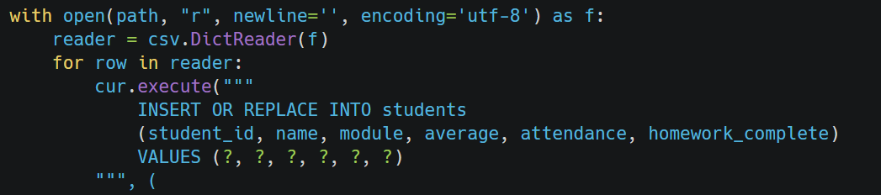

Issue 2: Invalid data types in CSV files
Early testing showed that importing text values into numeric fields such as average score or attendance caused runtime errors.
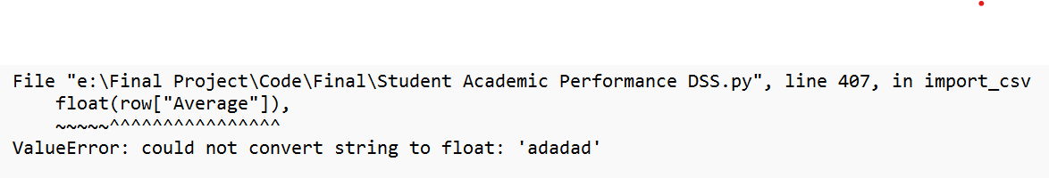

Solution:
Data type conversion was added using float() and exception handling (ValueError) was implemented. This prevents the program from crashing and displays a clear error message to the user when incorrect data is detected.
Issue 3: Missing columns in CSV file
If a CSV file did not contain all required column headers, the program raised a KeyError, stopping the import process.
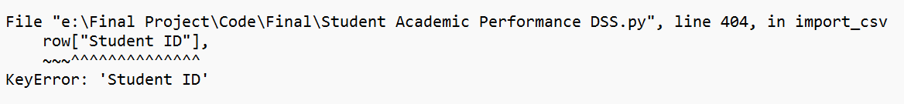
Solution:
A KeyError exception handler was added to detect missing columns and display a helpful error message. This informs the user of the problem and prevents invalid data from being imported.
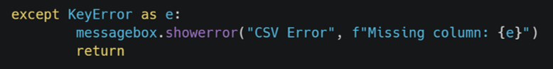

Evaluation
The CSV export feature successfully meets its objective by allowing student records to be exported in a widely compatible format. It integrates well with the existing database and user interface, supports administrative tasks, and makes the system more practical for real-world use.
The modular design of the feature also allows for future improvements, such as exporting filtered records or supporting additional file formats. Overall, the functionality enhances the usefulness and flexibility of the system.
Iteration 5 – Sorting Algorithm (08-3-2026)
Objective
The aim of this iteration was to allow teachers to sort student records so that academic performance could be analysed more easily and patterns within the data could be identified.
Implementation
A Bubble Sort algorithm is used to sort a list of student objects by repeatedly comparing and swapping neighbouring records when they are in the wrong order. Each student is assigned a tuple-based comparison key containing attributes such as student ID, name, module, and average score, allowing multi-criteria sorting using lexicographical comparison. The algorithm also supports both ascending and descending order, controlled by a Boolean flag, making the sorting flexible and adaptable.
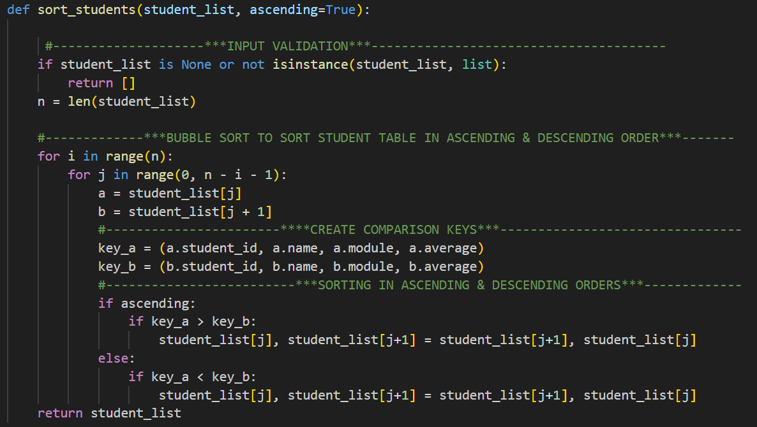
Code snippet

Justification
A Bubble Sort algorithm was used to sort the list of student objects as the dataset is small, making a simple algorithm sufficient without adding unnecessary complexity. Bubble Sort is easy to understand and implement, which is suitable for an educational application. The algorithm uses a tuple-based comparison key (student ID, name, module, and average score), allowing Python to perform multi-field sorting. It also supports both ascending and descending order using a Boolean parameter, improving flexibility. Input validation ensures only valid data is processed, increasing reliability. Overall, the design prioritises simplicity, readability, and functionality.

Testing
Test Case | Test Description | Input Data | Expected Outcome | Result
Valid sort (ascending) | Sort list in ascending order | List of student objects | Students sorted correctly | Pass
Valid sort (descending) | Sort list in descending order | List of student objects | Students sorted correctly | Pass
Multiple attributes | Sort students with similar values | Mixed student records | Correct secondary sorting applied | Pass

Problems Encountered and Solutions
Sorting comparisons not working correctly
Initially, clicking the Sort button in the main window always produced the same ordering of student records. Users could not switch between ascending and descending order, which limited the usefulness of the sorting feature and caused confusion during testing.
Solution:
The issue was resolved by introducing a Boolean control variable called sort_ascending. This variable tracks the current sort direction and allows the sorting order to toggle each time the Sort button is pressed.
The sort_students_ui() function was updated to:
- Pass the current sort direction to the sorting algorithm
- Reverse the sort direction after each button press
- Refresh the table to display the newly sorted data

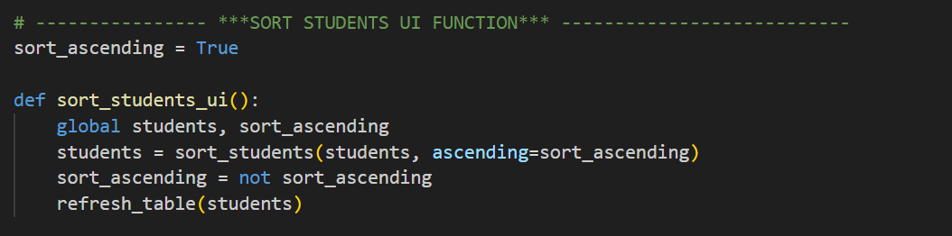
Code snippet
Toggles between ascending and descending sorting of the student list and updates the table display.

Evaluation
The sorting module now works reliably and meets its intended purpose. It allows student records to be organised clearly, supports different viewing needs, and integrates well with the user interface. The simple design makes the function easy to understand and maintain, while still providing effective sorting functionality for the system.
Iteration 6 – Searching Algorithm (08-3-2026)
Objective
The aim of this iteration was to enable users to locate individual student records by searching using either a student ID or a student name. At the same time, the system enforces role-based access control, ensuring that teachers can view multiple student records, while parents are restricted to viewing information related only to their own child.
Implementation
The search functionality was implemented using a linear search algorithm, as the dataset size is small and does not require a more complex approach. Each student record is checked sequentially to determine whether the search term appears in the student’s name or student ID. This provides a clear and efficient solution appropriate for the scale of the system.
To improve robustness, the search is performed in a case-insensitive manner, ensuring users can find records without exact formatting. Input validation is applied before the search using a separate function. This ensures the search term is not empty and follows valid formats for student IDs and names. If the user cancels the search or enters invalid input, the system exits safely and displays clear feedback, preventing unnecessary processing.
Once results are found, role-based behaviour is applied. Teachers can view all matching records within the table, supporting administrative tasks. Parents are restricted to viewing only the first matching student’s details, including performance indicators such as predicted grade and intervention. This enforces data privacy and aligns with real-world data protection requirements.

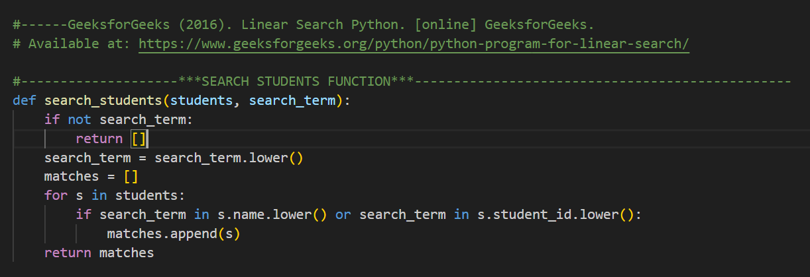
Code Snippets

Performs a linear search through the student list, returning all records where the name or student ID matches the search term (case-insensitive).

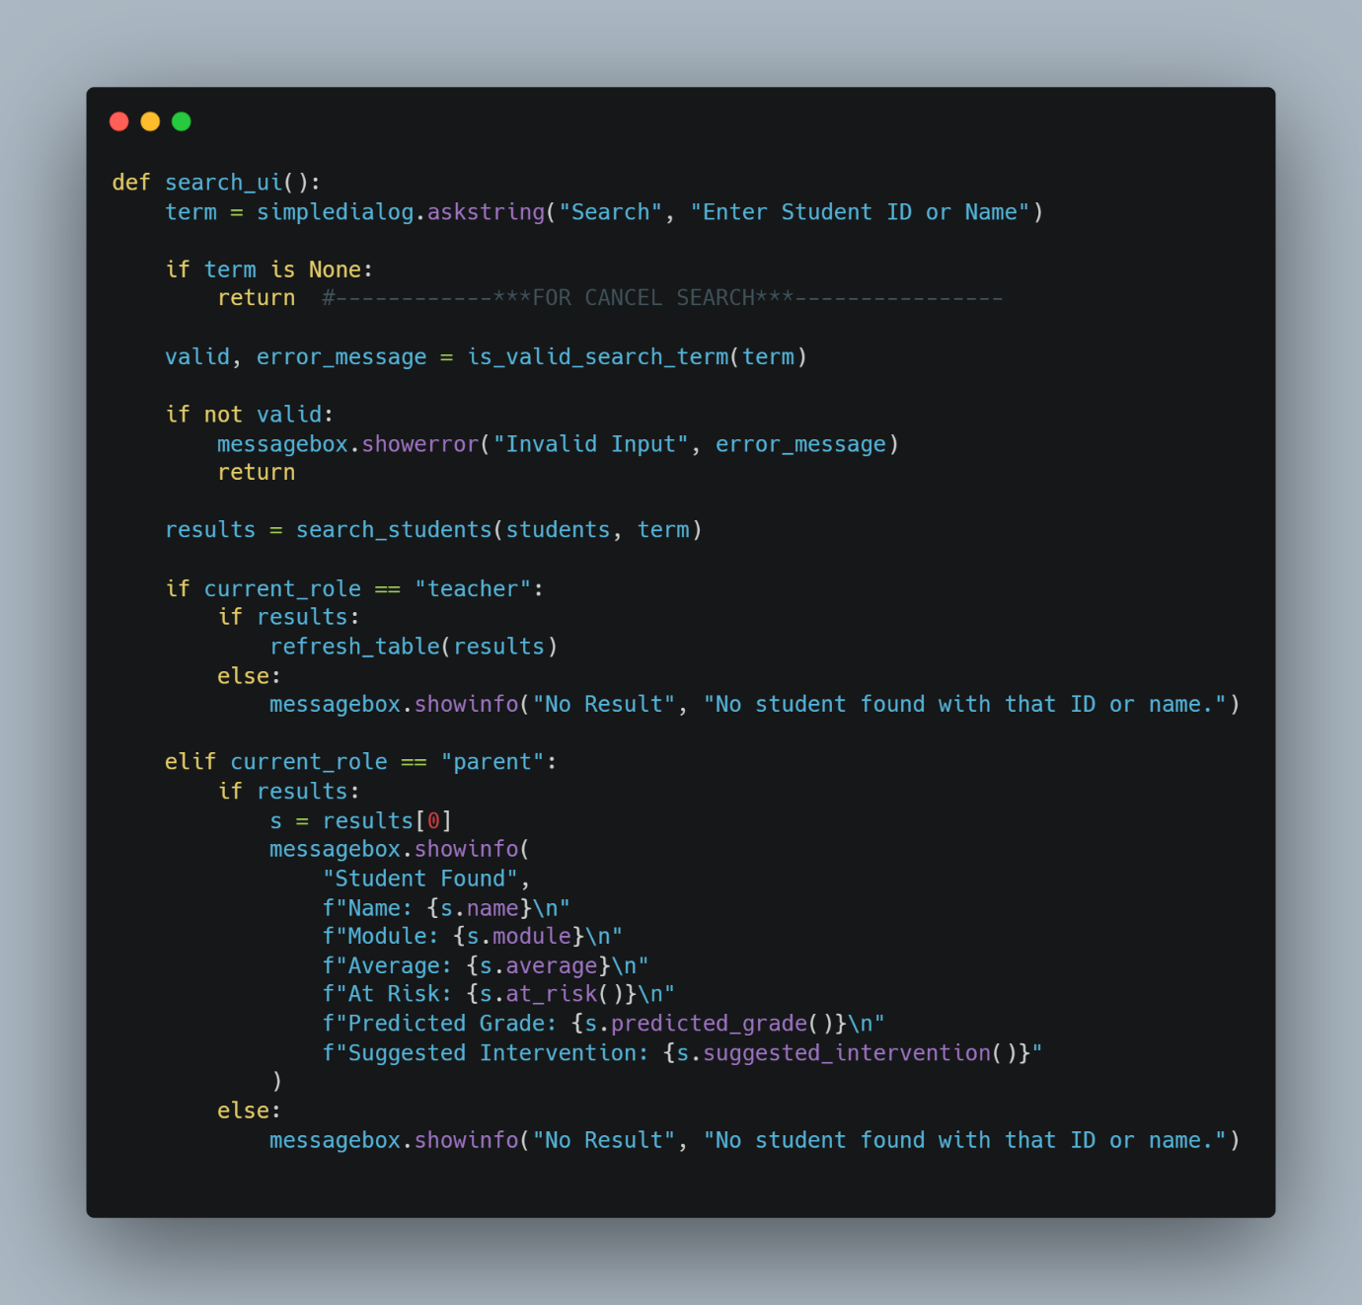

Prompts the user to search for a student by ID or name and displays results differently based on their role (teacher or parent).

Test cases
The following test cases were carried out to verify the search functionality of the system

Test Case | Input Data | Expected Outcome | Result
Valid student ID | S12 | Matching student returned | Pass
Valid student name | Daniel | Matching student(s) returned | Pass
Case-insensitive search | dAnIeL | Match found regardless of case | Pass
Partial match | Dan | Student(s) with matching name returned | Pass
Empty input | "" | Validation error message displayed | Pass
Cancel search | Cancel dialog | Search exits safely with no action | Pass
Invalid characters | @@@ | Validation error message displayed | Pass
Non-existent ID | S99 | “No student found” message displayed | Pass
Teacher role search | Valid name | Table refreshed with matching results | Pass
Parent role search | Valid ID | Student details shown in popup only | Pass

Problems Encountered and Solutions
Issue 1: Invalid search input caused unexpected behaviour
Problem:
Early testing showed that empty input or invalid characters could be entered, which led to unnecessary searching or unclear system behaviour.
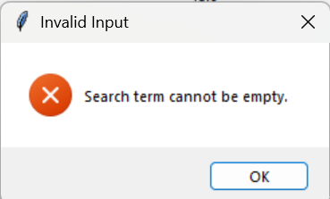
Solution:
A separate validation function (is_valid_search_term) was implemented to check input before performing the search. Invalid input now triggers a clear error message, and the search does not proceed. This improves robustness and user feedback.

Error message for empty inputs

Issue 2: Case-sensitive searches returned no results
Problem:
Initially, searches failed if users entered names or IDs with different capitalisation.
Solution:
Both the search term and student attributes were converted to lower case before comparison. This made the search case-insensitive and improved usability.
Issue 3: Parents could potentially view multiple records
Problem:
Without role-based logic, parents could view search results in the same way as teachers.
Solution:
Role-based behaviour was added. Teachers can view all matching results in the table, while parents are restricted to viewing only the first matching student’s details. This protects sensitive data and enforces access control.
Issue 4: No feedback when no results were found
Problem:
When a search matched no records, the system initially gave no response.
Solution:
An informative message box was added to notify users when no matching student is found. This improves clarity and user experience.
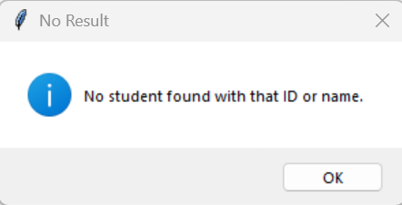
Validation for the invalid inputs

Evaluation
The search algorithm now works reliably and securely. Input validation prevents incorrect data from being processed, while role-based access control ensures data privacy. Testing and user feedback guided improvements, resulting in a user-friendly and robust feature that integrates effectively with other decision-support components of the system.

Iteration 8 – Module Grade Distribution and Visual Analytics (11‑03‑2026)
Objective
The aim of this iteration was to allow teachers to visually analyse student performance within a specific module. By displaying the distribution of predicted grades in graphical form, the system supports quicker interpretation of trends and patterns, enabling more informed academic decision-making.
Implementation
The module grade distribution feature uses Matplotlib, a Python data visualisation library, to create a pie chart showing the predicted grades for a selected module. Matplotlib allows data to be presented graphically, making it easier to interpret patterns and trends compared to raw data. The user is prompted to enter a module name, and the system filters the relevant students in a case-insensitive way. If no students are found, a message is shown and the process stops safely.
For the matching students, each predicted grade is calculated and stored in a list. The system then counts the frequency of each grade and passes this data to Matplotlib to generate a pie chart. The chart displays the proportion and percentage of each grade, along with a clear title, providing an easy-to-understand visual summary of overall module performance. In the parent view, this graph is included in the generated PDF report to give a clear overview of the module’s grade distribution.
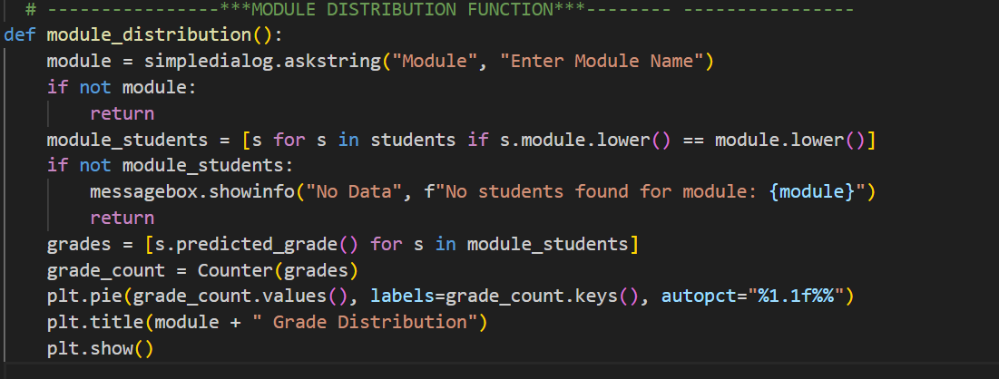
Code snippet

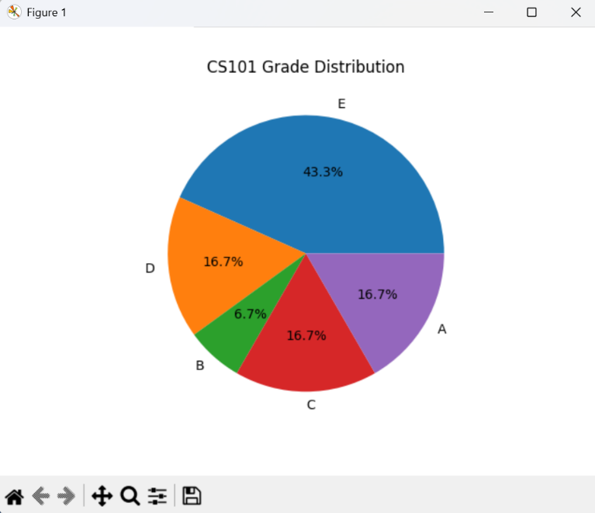

Justification
The module grade distribution feature uses Matplotlib to generate a pie chart showing predicted grades for a selected module. Graphical visualisation is used to help users interpret data quickly, with pie charts effectively displaying grade proportions. The system prompts the user for a module name and filters student records in a case-insensitive manner, ensuring relevant results and handling cases where no data is found.
For matching students, predicted grades are calculated dynamically and their frequencies are counted using a Counter. This data is then used to create a pie chart with percentage labels and a clear title. The feature provides a quick visual summary of overall module performance, and in the parent view, the chart is included in the generated PDF report.
Testing
The following test cases were executed to verify the module distribution functionality of the system.
Test Case | Input | Expected Result | Result
Valid module | M205 | Pie chart displayed | Pass
Valid module (lower case) | m205 | Pie chart displayed | Pass
Invalid module | M999 | “No students found” message | Pass
Empty input | Cancel / blank | Function exits safely | Pass

Problems Encountered and Solutions
Issue 1: Case-Sensitive Module Matching
Initial testing showed that entering a module name with incorrect capitalisation resulted in no data being found.
Solution:
Both the user input and student module values were converted to lower case before comparison, making the search case-insensitive and improving usability.
Issue 2: No Feedback When Module Was Not Found
Early versions of the feature produced no visible response when no students were enrolled in the specified module.
Solution:
A user-friendly message was added to inform the user when no data is available for the selected module.
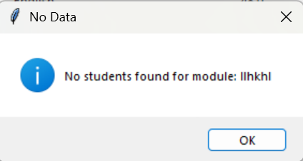
Validation message for an invalid module name
Evaluation
The module grade distribution feature successfully meets its objective by providing a clear visual representation of student performance within a module. It integrates effectively with existing analytical functions such as predicted grade calculation and supports informed decision-making. The feature enhances the system’s analytical capabilities and provides a strong foundation for future developments, such as exporting charts or combining multiple modules in a single visualisation.

Iteration 9 – Student Performance Report Export (PDF) (11‑03‑2026)
Objective
The objective of this iteration was to allow teachers and parents to generate a detailed academic performance report for an individual student. The report combines key performance data with visual analysis in a professional PDF format that can be saved, shared, or reviewed outside the system.
Implementation
This feature uses the ReportLab library, which allows Python to create professional PDF documents, along with Matplotlib for generating charts. When the export function is used, the system checks the user’s role: parents search for their child by ID or name, while teachers select a student from the table, ensuring that sensitive data is accessed appropriately. The system collects all relevant information for the student, such as average score, attendance, homework completion, at-risk status, predicted grade, and suggested intervention. It also looks at all students in the same module to calculate the predicted grade distribution. A pie chart is then created using Matplotlib and added to the PDF, giving a clear, visual summary of student performance.

Code snippet
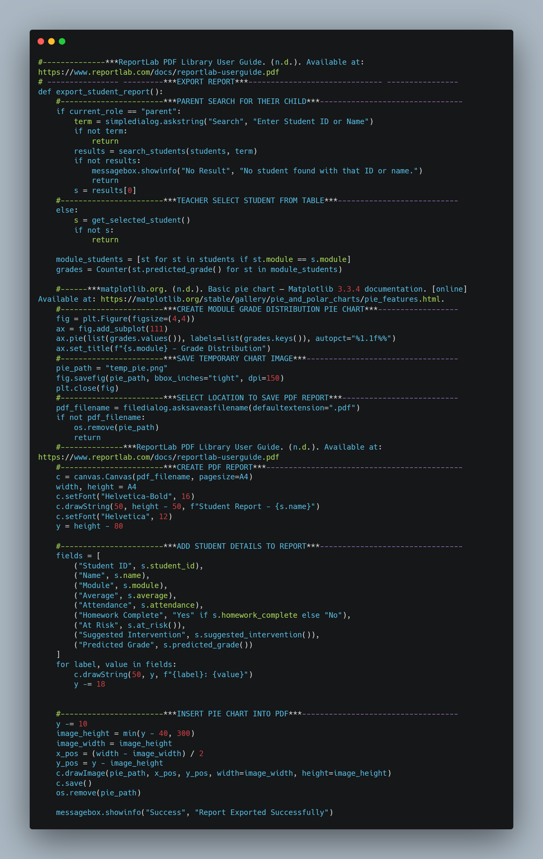
Sample PDF Report
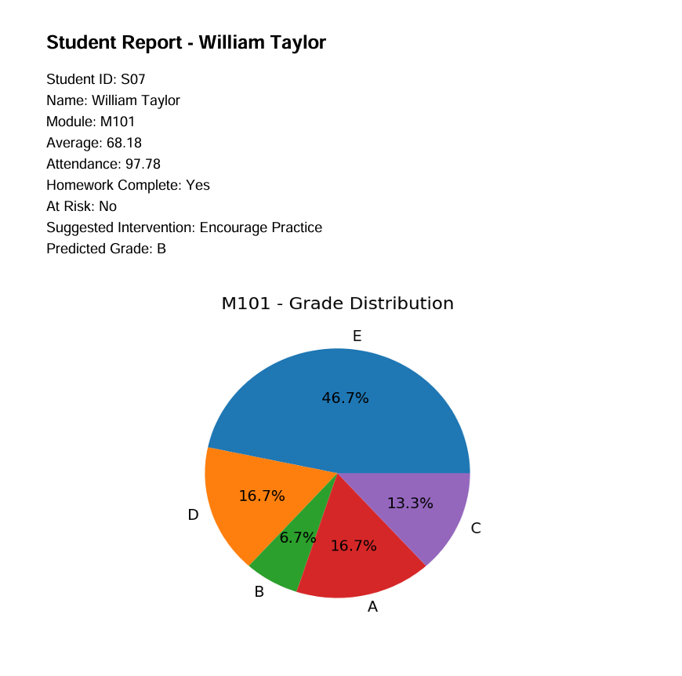

Test cases
The following test cases were executed to verify the PDF report generation functionality of the system.
Test Case | Input | Expected Outcome | Result
Teacher report export | Teacher selects a student and clicks Export Report | PDF report generated successfully | Pass
Parent report export | Parent searches valid student ID/name | Correct PDF report generated | Pass
Cancel student search (parent) | Parent cancels search dialog | Cannot export PDF without a valid student id/name | Pass
Cancel save dialog | Cancel file save dialog | Export cancelled, no PDF created | Pass
Pie chart generation | Student in a module with others | Chart included in PDF | Pass
Single-student module | Only one student in module | Pie chart generated correctly | Pass

Problems Encountered and Solutions
The PDF report was generated without including the module distribution pie chart.
Solution:
ReportLab cannot directly embed a Matplotlib figure object. To solve this, the pie chart was first saved as a temporary image file, which was then inserted into the PDF. After embedding, the temporary file is deleted to keep the system clean and prevent unnecessary storage use.
Code to save as a temporary image file
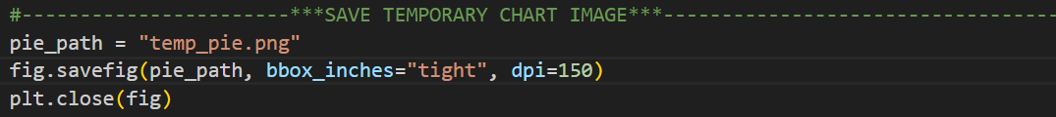

Justification
The report generation feature uses ReportLab to create professional PDFs and Matplotlib to include a visual grade distribution. The system identifies the student based on the user’s role. Parents search for their child, while teachers select from the table, ensuring sensitive data is protected. It collects key academic information, calculates predicted grades for the module, and generates a pie chart, which is embedded in the PDF.
Users choose where to save the report, and temporary files are removed after export. The PDF includes a clear title, student details, and the grade distribution chart. Using PDFs ensures formatting is preserved across devices, while combining text and visuals makes the report informative. Role-based access keeps data secure, and the modular use of Matplotlib and ReportLab ensures maintainability. Overall, this feature provides a clear, professional summary of academic performance, supporting the system as a decision support tool.

Evaluation
This iteration successfully met its objective by providing a clear, well-structured student performance report. The combination of textual data and visual analysis improves understanding and supports informed decision-making. The feature integrates effectively with existing system components and enhances the overall usefulness of the application.

Iteration 10 – Login System and Role-Based User Interface (15-03-2026)
Objective
The objective of this iteration was to control access to the system by introducing a login mechanism and to adapt the user interface according to the role of the logged-in user. This ensures that teachers and parents are presented with appropriate functionality and that sensitive student data is protected through role-based access control.
Implementation
The login system was implemented using a simple authentication mechanism based on predefined user credentials. When a user attempts to log in, the system retrieves the username and password entered in the login fields and checks them against stored user records.
If the entered credentials are valid, the user’s role is determined and stored in a global variable. A confirmation message is displayed, the login window is closed, and the main application window is launched. The main interface is then built dynamically based on the user’s role.
If the credentials are invalid, an error message is shown, and access to the system is denied. This prevents unauthorised users from accessing the application.
A reset function was also implemented to allow users to quickly clear the login fields. This improves usability and reduces frustration if incorrect details are entered.

Role-Based Interface Construction
Once a user logs in successfully, the build_main_window function creates the main interface and displays features based on their role. Teachers have access to administrative tools such as importing CSV files, refreshing data, sorting records, viewing module grade distributions, and accessing full student tables. Parents have restricted access, allowing them to search for a student and view performance-related information while protecting data privacy.
All users can search for students, view at-risk status, predicted grades, suggested interventions, and export reports. The main student table, displayed only for teachers, uses a scrollable TreeView to ensure easy navigation of large datasets.
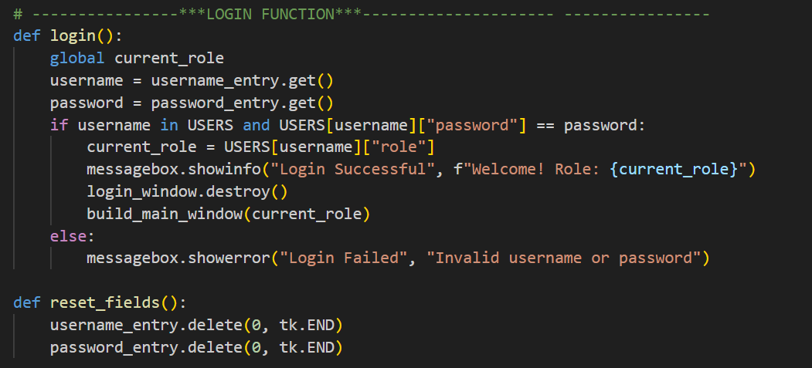
Code snippets
Verifies user credentials, assigns the appropriate role, and opens the main interface upon successful login.

Clears the username and password input fields to allow the user to re-enter credentials.

Justification:
The login feature ensures that only authorised users can access the system. When a user enters their username and password, the login() function checks these against stored records and assigns a role, which determines what features they can see and use. This keeps sensitive student data secure and ensures teachers and parents only access information relevant to them.
The reset_fields() function lets users quickly clear the input fields, making the login process easier and more user-friendly. Using Tkinter provides a simple, intuitive interface, and keeping the login logic separate from the main interface makes the system easier to maintain and extend in the future.
Testing
The login and role-based interface functionality was tested using a range of scenarios.
Test Case | Input | Expected Result | Result
Valid teacher login | Correct credentials | Access granted, full interface shown | Pass
Valid parent login | Correct credentials | Access granted, restricted interface shown | Pass
Incorrect password | Wrong password | Error message displayed | Pass
Unknown username | Invalid username | Login denied | Pass
Empty fields | No input | Login denied | Pass
Reset fields | Click reset | Fields cleared | Pass

Problems Encountered and Solutions
Issue:
Initially, all users were shown the same interface regardless of their role.
Solution:
The interface was modified to dynamically display features based on the logged-in user’s role. Administrative tools and full data views were restricted to teachers only.
Evaluation
This iteration successfully introduced secure access and role-based user interaction. By combining authentication with a dynamically constructed interface, the system ensures usability, security, and ethical handling of student data. The solution integrates smoothly with existing components and provides a strong foundation for future improvements, such as enhanced authentication or additional user roles.

